os Module in Python
The os module in Python is a built-in library that provides functions for interacting with the operating system. It allows you to perform a wide variety of tasks, such as reading and writing files, interacting with the file system, and running system commands.

Here are some common tasks you can perform with the os module:

Reading and writing files
The os module provides functions for opening, reading, and writing files. For example, to open a file for reading, you can use the open function:

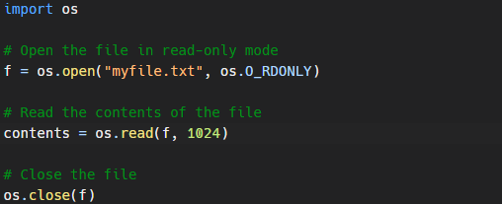
To open a file for writing, you can use the os.O_WRONLY flag:

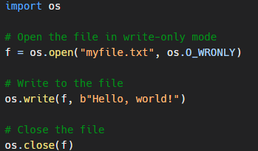
Interacting with the file system
The os module also provides functions for interacting with the file system. For example, you can use the os.listdir function to get a list of the files in a directory:

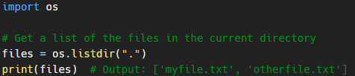
You can also use the os.mkdir function to create a new directory:

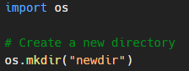
Running system commands
Finally, the os module provides functions for running system commands. For example, you can use the os.system function to run a command and get the output:

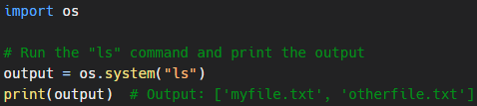
You can also use the os.popen function to run a command and get the output as a file-like object:
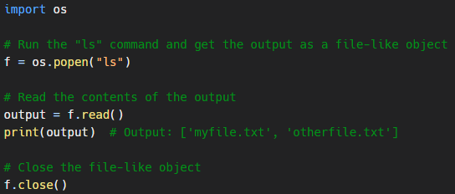
In summary, the os module in Python is a built-in library that provides a wide variety of functions for interacting with the operating system. It allows you to perform tasks such as reading and writing files, interacting with the file system, and running system commands.

